4101607/4101707/4101907
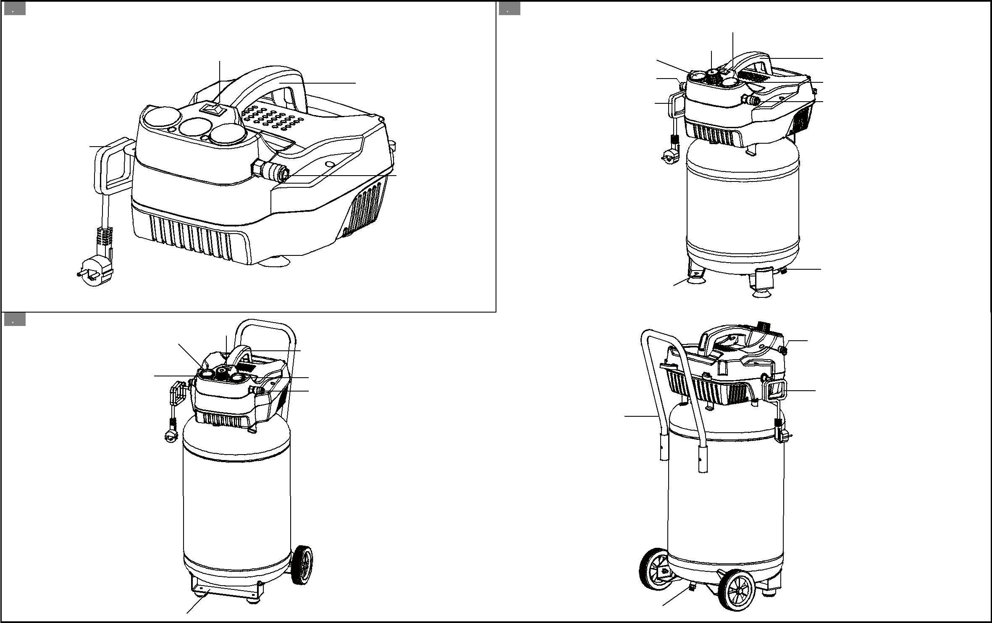

1. | 2.
 |  | 5 | 8
3 | 7 |  | 1
1 | 2 |  | 6
 | 10 |  | 3

4

2

 |  |  | 4
 |  |  | 9
 |  | 4101607 | 4101707
3. |  | 8 | 4.
 | 7 |  | 2
 |  | 1
5 |  | 6 | 10
 |  | 3
 |  |  | 11

9 ⁴ 4101907

